

School of mechanical and manufacturing engineering, **NUST**

Department of mechanical engineering

# CS-114-Fundamental of programming Hometask # **4**

Course Instructor : Dr Khwaja Iqbal Lab Instructor : **M. Affan**

Name : **Zoraiz Abbas**

CMS ID : **454752**

# DATE: 26 Oct 2023

## Task 1:

Write a program in C++ that prints the numbers from 1 to 150 except the multiples of

10. Make use of the continue statement.

## Answer :

#include <iostream> using namespace std; int main(){

for (int i=1;i<=150;++i) { if(i%10==0) {

continue;

}

cout<<i<<""<<endl;

}

return 0; }

## Result:

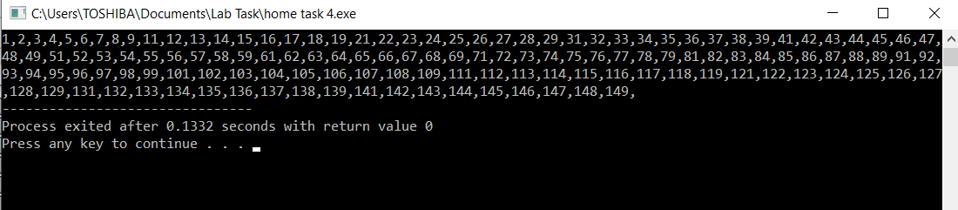

Task 2:

Write a C++ program to find the sum of digits of a number. The sum of digits means adding all the digits of any number, for example, we take any number like 358. Its sum of all digits is 3+5+8=16.

## Answer:

#include<iostream> using namespace std ; int main(){

int num,sum=0;

cout<<"enter the number"<<endl; cin>>num;

while(num>0)

{

sum+=num%10; num/=10; } cout<<sum<<endl;

return 0; }

## Result:

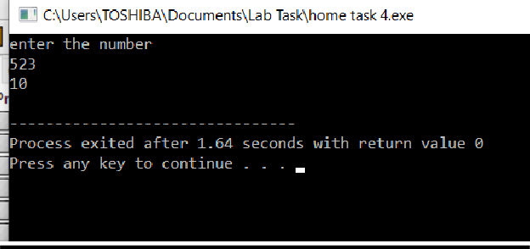

**Task 3:**

Write a program in C++ to check whether a number is prime or not.

## Answer:

//program to check whether a number is prime or not #include <iostream>

using namespace std;

int main() {

int num, i, m=0, fop=0;

cout << "Enter the Number to check prime number: "; cin >> num;

m=num/2;

for(i = 2; i <= m; i++)

{

if(num % i == 0)

{

cout<<"Number is not Prime."<<endl; fop=1;

break;

} }

if (fop==0){

cout << "Number is Prime."<<endl;

}

return 0; }

## Result:

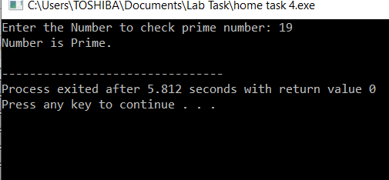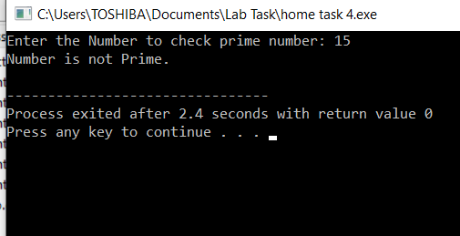

**The End**